# Report: Unreal Engine

Name: Benjamin Fekete

Id: 102946740

## What is unreal Engine?

Unreal engine (made by Epic Games) is a c++ based engine utilizing custom frameworks for graphics, audio and windows. Unreal projects can use c++, a visual scripting called blueprint, a versatile visual coding language making use of “nodes” to conduct c++ based functions (when compiled, blueprints turn to c++).

Unreal is focused on high end graphics, with realism, in depth material editing (fancy textures), a lighting system named lumin, and tons of features that allow people to meticulously change features on 3d models. With more features to increase performance like the new built in dynamic LoD (level of Detail) system called nanite, making models edit their poly count dynamically based on distance from camera.

Unreal engine is mainly focused on Video Games Development, however in more recent times has dipped into other industries such as architecture, military simulation and live visual effects for shows and movies.

## Making Games

To start your project you simply just need to download a version of unreal engine from the epic games launcher. Launch and create project, selecting c++ or blueprint project. From there you can set the project name and graphics settings (low, medium, high, epic).

Unreal has a multitude of different assets, such as Blueprints, Materials and Levels. Each type of asset serves a purpose with complete modularity. The Actor Blueprint (a child of object class) is used as a base for other classes such as Pawn used for player and ai control, game mode use to control things like base player pawn, UI, base controller and other features, and controller, broken down to player and ai controller used to interface with input from sources like a controller for player and a “behavior tree” for ai.

Materials are like textures on steroids, they an extremely versatile asset that can be applied to a mesh allowing you to edit values such as colour, emissive light, animation, opacity and a whole list of extra functionalities that allows artists to create the perfect material for their assets.

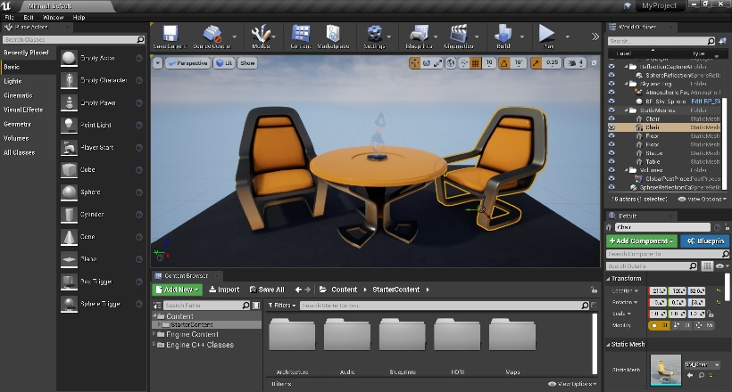The level asset is a container for actors, meshes, volumes and landscapes used together to build worlds. Each level is loaded separately, making use of the state and factory design patterns.

Unreal makes use of multiple design patterns out of the box, Such as Component-Based Architecture for its actor blueprints. Actors can be broken down into individual pre made (and custom) components such as movement component (for character movement), skeletal mesh and perception (for ai sensory). Other design patterns include Figure 1: Unreal Engine 5 Editor

Singleton, Observer, Decorator, Strategy, Command, Iterator, Mediator and visitor (not limited). Each object will serve a purpose and make use of one of or multiple design patterns.

Most Unreal projects makes use of both c++ and blueprints, c++ is generally used for complicated and low level tasks such as complex math, graphics calls and highly complex tasks that require fast processing. Where as blueprints are used for high level programming, materials and prototyping. Making use of both effectively will save time and performance, however there is no correct way to make a game as you can make a game entirely in blueprint and have great performance.

## Platforms

Unreal supports Windows, MacOS, Linux, Nintendo Switch, Xbox Family, Playstation 4/5, IOS and Andriod. Most can be compiled from a single platform but apple products require an apple device to compile.

## Other use cases

In the movie industry, especially Disney, has been using Unreal Engine to create “Live Visual Effects” trough a method that involves the use of a large room covered in LCD Screen playing the visual effects as the scene is being recorded live. This has been

done in shows such as The Mandalorian, Guardians of the galaxy Vol.2 and The Matrix. 

Figure 2: Madalorian Set

Unreal has also been used in the architecture world, with its easy to use tools for editing levels you can create to scale buildings with accuracy.

Simulation is another industry, especially in military, testing designs and systems for vehicles. This is done well with the “Choas” physics system, giving accurate physics simulations for vehicles, allowing the ability to edit mass, velocity and collision.

## Example Games

Tripple A Games such as Mortal Kombat (since the 9th installment) has been made in unreal, other games include Valorant, Ark, Fortnite and so many more. Most companies get special pricing for royalties but the royalties stary after the first $1,000,000 and you only need to pay 5%, making it appealing to the indie industry with games such as Pal World, Satisfactory, Astroneer and Stray. \

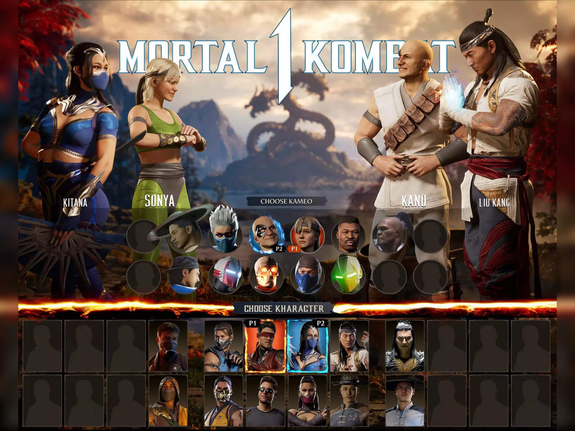

Figure 3: Mortal Kombat 1 Made in Unreal Engine

Epic Games. (2023). *Unreal Engine | The most powerful real-time 3D creation tool*. Unreal Engine; Epic Games. <https://www.unrealengine.com/en-US>

Unreal Engine; Epic Games. <https://www.unrealengine.com/en-US/uses/switching-to-unreal-engine>

Unreal Engine; Epic Games. <https://www.unrealengine.com/en-US/uses/film-television>